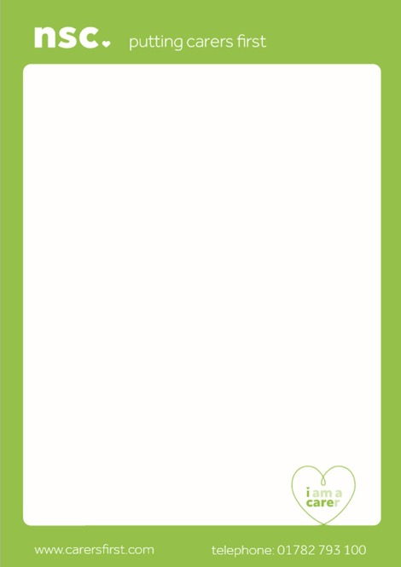

**Do You look after someone due to age, illness, disability, or addiction?**

**If the answer is YES**

**YOU ARE A CARER**

**Please let your GP reception know so that you are recognised for your caring role and added to the GP Carers Register.**

**Also find out about the support that is available to you from North Staffs Carers**

CARERS REGISTER